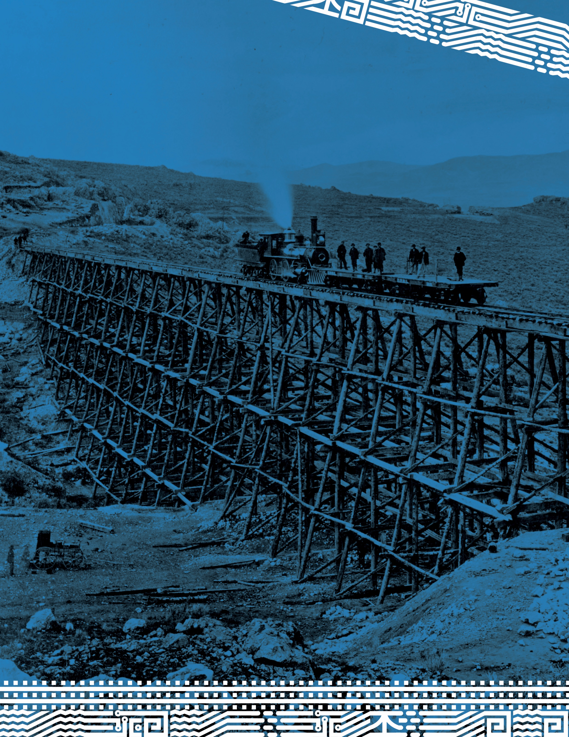

Mormon Workers and the Transcontinental Railroad

GRADE 7
Mormon Workers and the Transcontinental Railroad
By Brittany Roper
Summary
Students will read about the Mormon men who helped build the first transcontinental railroad through Utah. They will then analyze and draw conclusions based on what they read.
Main Curriculum Tie
UT Standard 2.5: Students will construct an evidence-based argument to explain how the development of transportation and communication networks across the state changed Utah’s economy and human geography.
Additional Curriculum Ties
UT Standard 2.1: Students will explain the causes and lasting effects of the Mormon migration to Utah.
Reading- Literature Standard 10: By the end of the year, read and comprehend literature, including stories, dramas, and poems, in the grades 6–8 text complexity band proficiently, with scaffolding as needed at the high end of the range.
Time Frame
One time period that runs 40 minutes
Group Size
Small groups or individuals
Life Skills
Employability and Thinking & Reasoning
Bibliography
ARTstar. A Map of the Union Pacific Railroad Route and Its Connections. 1868.
“FAQ's.” Central Pacific Railroad Photographic History Museum, 25 Oct. 2017, cprr.org/Museum/FAQs.html.
“Frequently Asked Questions.” National Parks Service, U.S. Department of the Interior, www.nps.gov/gosp/faqs.htm.
King, David S. Driving of the Golden Spike at Promontory, Utah, 1869. Salt Lake City, 3 Mar. 2009.
“Original Land Titles in Utah Territory.” Utah.gov, Utah Division of State Archives, 1 Apr. 2003, archives.utah.gov/research/guides/land-original-title.htm.
Rumel, Hal. Brigham Young. Salt Lake City, 5 July 2006.
Russell, Andrew J. Union Pacific Railroad -Construction P. 31. Salt Lake City, 9 Dec. 2008.
Stevens, Thomas M. “The Union Pacific Railroad and the Mormon Church, 1868-1871: An In Depth Study of the Financial Aspects of Brigham Young's Grading Contract and Its Ultimate Settlement.” Brigham Young University, August 1972.
Stewart, John J. “The Iron Trail to the Golden Spike.” Central Pacific Railroad Photographic History Museum, cprr.org/Museum/Stewart-Iron_Trail.html.
“Union Pacific.” Union Pacific, www.up.com/goldenspike/omaha-promontory.html.
Materials
Mormon Railroad Workers Reading
Mormon Railroad Workers Worksheet
Sticky note pad – standard size
Background for Teachers
The building of the first transcontinental railroad was a huge undertaking and people from all over the world came to help. The Central Pacific employed 12,000 immigrants from China, and the Union Pacific employed a combination of Irish immigrants, former Civil War soldiers, and convict labor. Once the railroad work approached the Utah Territory both railroad companies hired Mormons who had settled in Utah to help complete the tracks. The first transcontinental railroad was completed on May 10, 1869, at Promontory Summit in northern Utah.
Vocabulary:
Grading: The construction done to make sure the foundation is level or at a specified slope.
Surveying: Inspecting an area where construction is supposed to take place.
Primary Source: Something created at the time of the event, such as quotes, photographs, newspapers, and letters.
Secondary Source: Something written, said, or painted by someone who studied an event.
Student Prior Knowledge
Students should be familiar with the vocabulary words stated above. They should also know the difference between a fact and an opinion.
Intended Learning Outcomes
Students will be able to identify the sequence of events that occurred prior and during the construction of the transcontinental railroad in Utah.
They will be able to describe how the Mormons helped survey and construct part of the roadbed through Utah.
Instructional Procedures
- Draw a T-chart on the board. Label one side “Railroad” and the other “Mormon Settlers.” Hand one sticky note to each student have them write one thing that they already know about the Transcontinental Railroad or the Mormons who first settled in Utah. Have students place their sticky note under the correct column. Review their answers clearing up any misconceptions.
- Pass out “The Mormon Railroad Workers” reading and worksheet. Have students read and answer the questions either independently or in small groups.
- Review answers to the questions you feel would benefit your class the most.
- Have students turn in the worksheet.
- Close by having students share with a partner one thing they learned by reading the text.
Strategies for Diverse Learners
Allow students to partner up or read in a small group with the teacher. They could highlight the answers in the text and place the corresponding number next to the highlighted area instead of writing in on the worksheet.
Extensions
- Have students research another group of immigrants that helped on the railroad such as the Chinese or Irish.
- Have students explore this interactive map. Have them write down five-ten interesting facts. https://www.up.com/goldenspike/index.html
- Watch the KUED documentary Promontory!, which focuses on the Mormon’s involvement with the transcontinental railroad: https://video.kued.org/video/kued-local-productions-promontory/
Assessment Plan
Answers on the worksheet will be part of an informal assessment.

Mormon Workers and the
Transcontinental Railroad

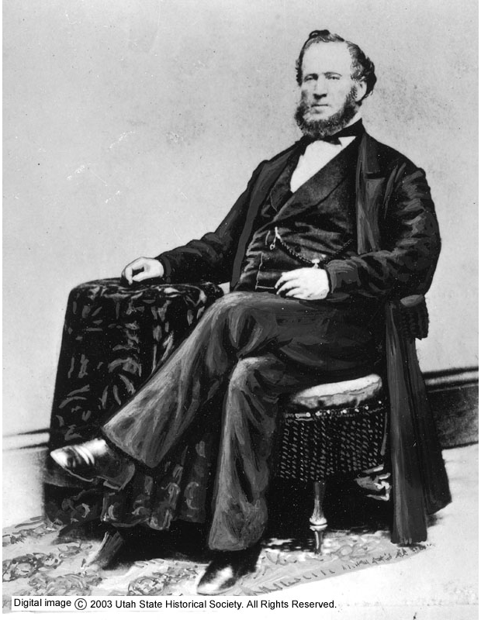
In July 1847, 15 years before the transcontinental railroad became a reality, a religious group from Nauvoo, Illinois called the Church of Jesus Christ of Latter-Day Saints, commonly known as “Mormons,” arrived in an area claimed by the Republic of Mexico. The following year the United States signed the Treaty of Guadalupe Hidalgo, which made present-day Utah part of the U.S.
Congress first considered building a transcontinental railroad in 1845, but postponed discussing the idea until a later, more convenient, date. In 1852, as discussions gained steam, Utah leaders sent a petition to Congress suggesting that the tracks should pass through Salt Lake City. Brigham Young, the leader of the Mormon church, announced that Utah would be willing to build a railroad if the government chose not to. However, Congress was focused upon the debate about slavery at the time, and again postponed a transcontinental railroad.
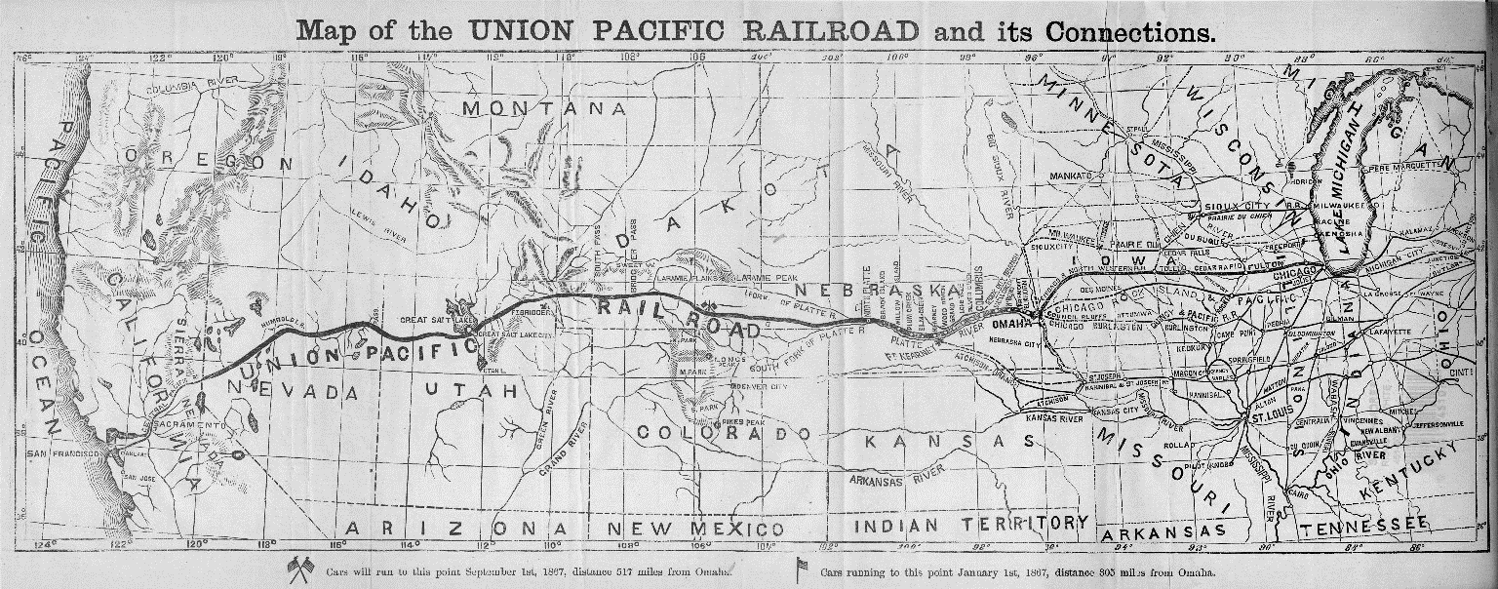
It was during the Civil War (1861-1865) that President Abraham Lincoln signed the Pacific Railroad Act on July 1,1862, which would make it possible to connect the East and West coasts via rail. Two companies were formed: The Union Pacific (UP), which would build westward from Omaha, and the Central Pacific (CP), which built eastward from Sacramento. Interested in the railroad, Brigham Young became one of the first stockholders of the Union Pacific.
In 1863 the UP began to survey the proposed route and by 1864, engineers had reached Utah Territory. Samuel B. Reed, superintendent of construction, met with Brigham Young and contracted with him for men and supplies to assist in the survey work. Reed was impressed with Young and his followers, and he contracted them again the following year to help with more surveying.
After the Civil War ended, additional money could be allocated to the railroad project and former soldiers needed employment. The UP benefited from the influx of available men, eager to work. By early 1868, the tracks were laid well into present-day Wyoming and company officials were certain that they would reach Salt Lake City before winter.
As survey and construction work neared Utah Territory, UP vice president Thomas C. Durant gave Brigham Young the opportunity to complete part of the roadbed from the head of Echo Canyon to the Great Salt Lake. Durant required the work to begin immediately and be completed before winter. The UP offered to provide all the tools and equipment needed for the work and transportation.
Young believed that the contract would benefit the people of Utah, because it would create jobs during construction as well as after the railroad began operating. He also realized that railroads would reduce the costs of goods transported to and from Utah, as well as the cost of overland passenger travel. Mormons would no longer have to migrate to Utah in covered wagons. Young agreed that Mormon crews would complete the tracks to Echo Canyon by the following November. He signed the contract with representatives from the UP on May 21, 1868. This gave the Mormons a million dollars’ worth of grading, tunneling, and bridge work from the Utah-Wyoming border to the undetermined juncture with the CP rails. In the contract, the UP promised that 80% of the contract price would be paid monthly and the other 20% would be paid at the completion of the project. Little did Young know that the UP would not honor these terms. He would not receive the promised monthly payments, making it difficult to buy the necessary supplies and take care of his men.
Brigham Young hired several subcontractors to manage the work, including his son Joseph Young and John Sharp, a bishop in the church. On May 30, 1868 Sharp and a crew of 50 men left Salt Lake City to begin carving out road beds from rocky hillsides in Weber Canyon. Sharp and his men were reported by the Deseret News to be “…as capable a body of “blasters” as well be got together; and they will make some big rocks tumble quickly. This is the first “gang” of graders for the distance between Echo Kanyon and the valley on President Young’s contract.”
Sharp and Young determined that the railroad would cross the Weber River near Devil’s Gate, and preparations were necessary before a bridge could be built. The Deseret News reported that despite experiencing several setbacks, Sharp and Young's camp was one of the best organized on the railroad.
By early September, Sharp and his crew had progressed as far as Lost Creek on the Weber River. There was still extensive rock removal to be done. They had also begun work on two tunnels in Weber Canyon. The work was not moving as quickly as hoped, but Sharp felt the major part of it, except for the tunnels, would be finished by November, per the contract.
Although Sharp had a hard time finding enough men who could leave their farms to work for him, more than 2,000 Mormon men worked on the railroad construction project. In comparison, about 12,000 Chinese immigrants built the CP rail line from California, and roughly 3,000 Irish immigrants worked for the UP and CP.
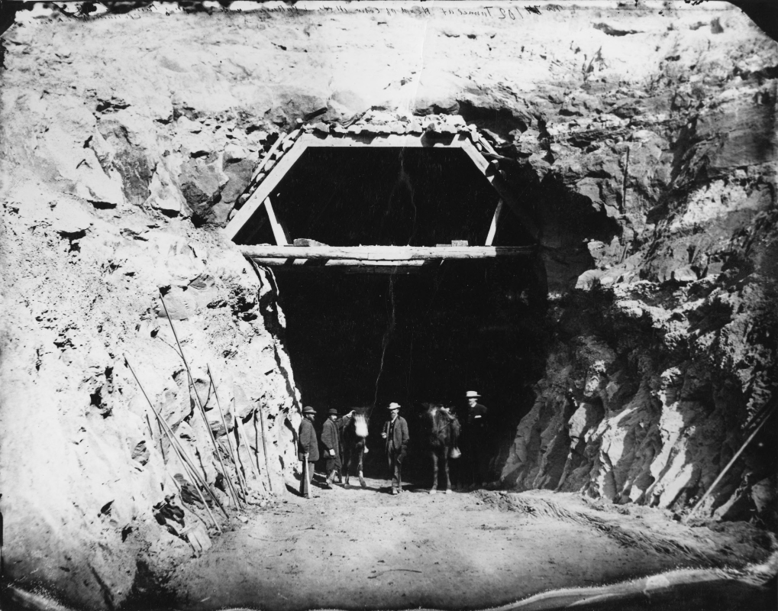
Meanwhile, the CP offered to hire Mormon crews to grade the roadbed from the Utah-Nevada line east into Weber Canyon. Brigham Young agreed to the contract only after the CP gave him a cash advance, which he demanded after the UP failed to meet its monthly payments.
By November the Mormon crews on the UP line realized they would have to work through the winter to complete the road. The grading in Echo Canyon was complete, as was most of the part west of Weber Canyon. However, the tunneling and a few other difficult rock points were not finished. Young was forced to ask the UP for an extension on his contract.
The UP was now worried that the tunneling would not be completed by the time the track reached Weber Canyon. The UP asked that Sharp withdraw his men, then replaced the Mormon workers with UP employees. Sharp did this without hesitation and Brigham Young was pleased with the turn of events. He felt that he had now escaped any repercussions from the UP for not having fulfilled his part of the contract.
However, the following month UP superintendent Samuel Reed decided that the railroad employees were making less progress than had been made by Sharp and Young. He asked the Mormons to resume work on the tunnels. Brigham Young bragged that the railroad had four men employed to every one man under Sharp and Young and still made less progress. He stated, “Bishop Sharp and Joseph A. Young are using the nitroglycerine for blasting, and its superiority over powder as well as the sobriety and steadiness and industry of our men, gives us a marked advantage.”
By the middle of April, the last tunnel through Weber Canyon was completed. No meeting point for the two railroads had yet been announced, and the competitiveness between the UP and CP resulted in them laying 250 miles of parallel grade from Echo, Utah, to Wells, Nevada. Finally, Congress realized that a meeting place had to be decided. They chose the midway point of the end of track for each railroad company, which happened to be Promontory Summit, north of the Great Salt Lake, 50 miles west of Ogden.
The festivities for the "Wedding of the Rails" took place on May 10, 1869. The Wellsville Free Press, in New York, wrote, "A little after 2 o'clock, Monday last, the telegraph noted the final completion of the grandest undertaking of modern times, that of laying 1,776 miles of continuous rail ... uniting the Atlantic to the Pacific." The distance between San Francisco and Omaha had now been bridged. The UP had completed 1,086 miles of tracks across Nebraska, Wyoming, and Utah, compared to 690 miles laid by the CP across the rugged Sierra Nevada mountain range. Samuel Bowles, one of the most influential American journalists of the nineteenth century, published a book, Our New West, in which he observed that "but for the pioneership [sic] of the Mormons, discovering the pathway, and feeding those who came out upon it, all this central region of our great West would now be many years behind its present development, and the railroad instead of being finished, would hardly be begun."
With the transcontinental railroad complete, Brigham Young sent representatives to Boston to demand payment, $1.2 million, for the work his men did for the Union Pacific. The UP was bankrupt and out of money. They could not pay their debt in cash. Instead, they made arrangements that allowed Mormon emigrants coming from Europe to travel the rails to Utah. Their fare would go towards the debt owed. They also gave Brigham Young $700,000 worth of railcars and supplies to help build a railroad to Salt Lake City. This type of payment would not help the workers, but Brigham Young accepted the terms the UP gave him. He knew it would be the best they would offer.

Name: ________________________________________

Mormon Workers and the Transcontinental Railroad

- Complete the timeline.

- _______________________________
- _______________________________
- _______________________________
- _______________________________
- _______________________________
- ______________________
- Young signed contract with CP

5/21/1868
7/1847
4/1861
7/1862
5/1865
9/1868
5/10/1869

- How did Brigham Young show his support for the transcontinental railroad?
____________________________________________________________________________________________________________________________________________________________
- What can you infer about how the end of the Civil War influenced the transcontinental railroad?
____________________________________________________________________________________________________________________________________________________________
- Before any of the grading or tunneling could be done, what were the Mormons contracted to do for the Union Pacific?

- Survey b. Build a bridge c. Gather supplies

- Why would both railroad companies be interested in signing a contract with the Mormons?

____________________________________________________________________________________________________________________________________________________________
- Name two locations where the Mormons worked on the railroad.
- ______________________________ 2. ______________________________

- What setbacks did the Mormon railroad workers face?
____________________________________________________________________________________________________________________________________________________________
- List one fact stated in the text.
____________________________________________________________________________________________________________________________________________________________
- List one opinion stated in the text.
____________________________________________________________________________________________________________________________________________________________
- List one primary source found in the text.
____________________________________________________________________________________________________________________________________________________________
- How did Brigham Young believe the Union Pacific contract would benefit the Mormons? Do you think he was correct?
____________________________________________________________________________________________________________________________________________________________
- Which railroad company or subcontractor would you have wanted to work for? Why?
____________________________________________________________________________________________________________________________________________________________
____________________________________________________________________________________________________________________________________________________________
______________________________________________________________________________

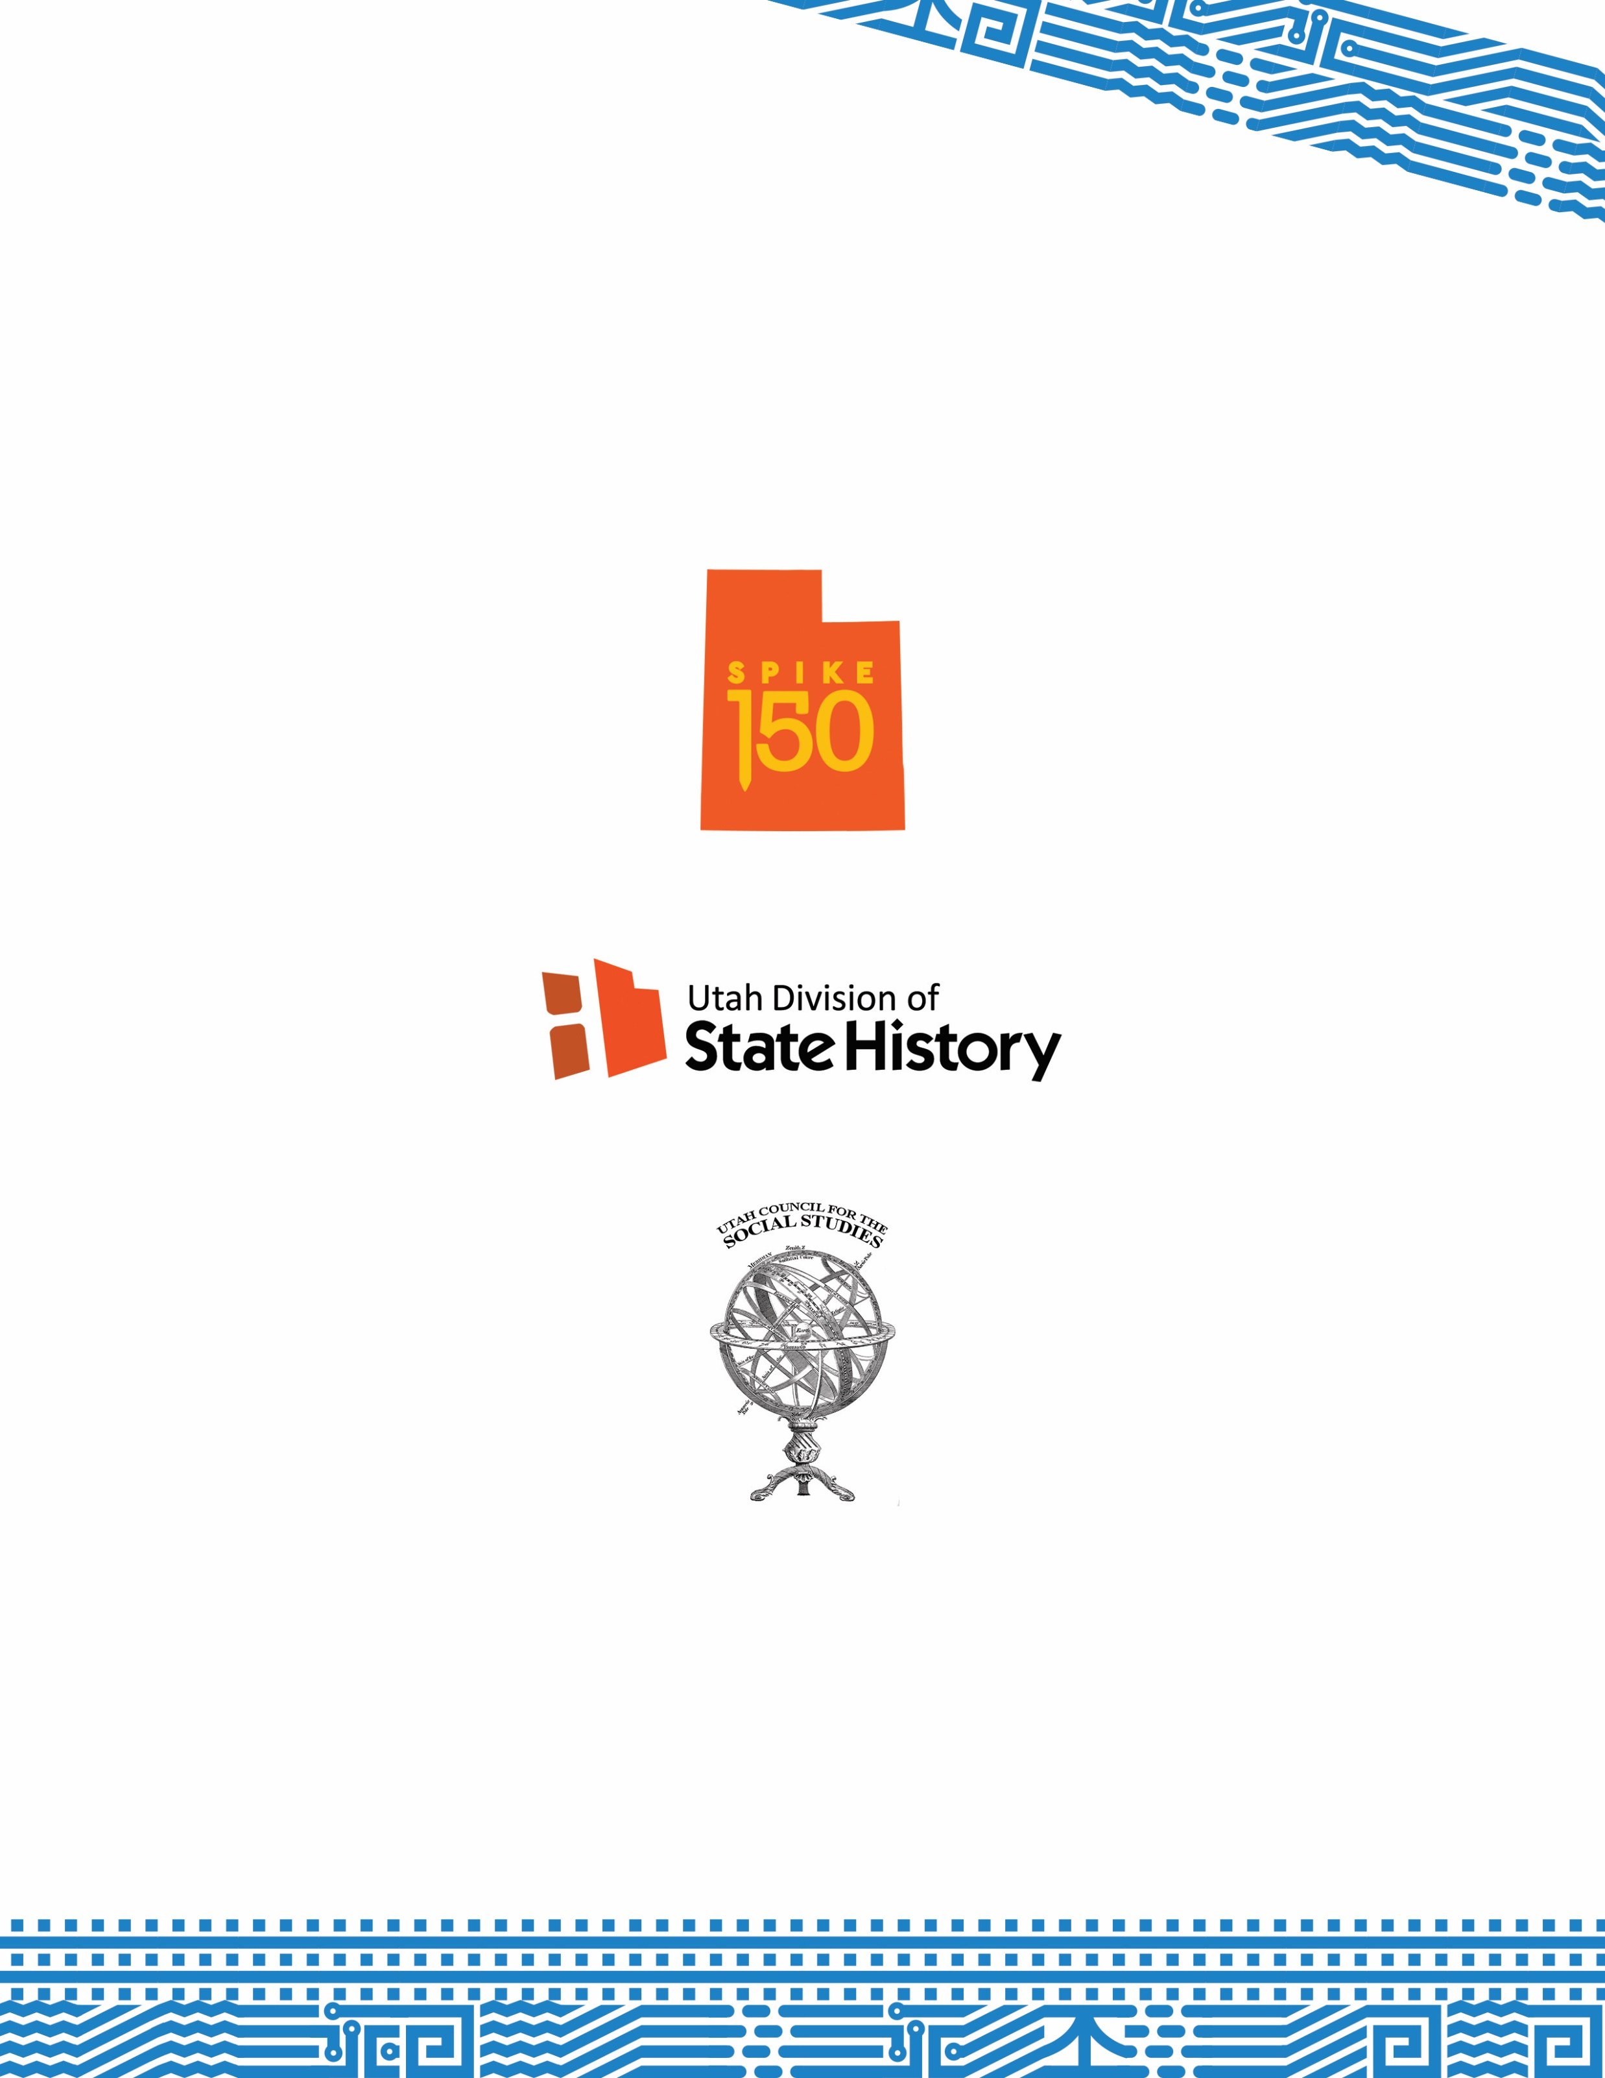
Lesson plans on the Transcontinental Railroad created with the support of Spike150, the Utah Division of State History, and Utah Council for the Social Studies.

