**ADDENDUM**

**Fashion Merchandising 1 7-2015**

**(Formerly Fashion Merchandising B)**

**(Fashion Design Merchandising, 2016-17 School Year)**

**Levels: Grades 10-12**

**Units of Credits: 0.50**

**CIP Code: 20.0316**

**Core Code: 34-01-00-00-145**

**Prerequisites: Fashion Strategies (Fashion Design Studio, 2016-17 School Year)**

**Skill Test: #405**

**COURSE DESCRIPTION**

The Fashion Merchandising course is an introductory course that teaches the concepts of entry-level business and fashion fundamentals. The following list of skill standards prepares the student in fashion merchandising with the fundamentals of: basic fashion concepts and marketing terminology, fashion cycles, key components of the fashion industry, retail merchandise categories, fashion promotion, fashion marketing, and fashion careers. This course will strengthen comprehension of concepts and standards outlined in Sciences, Technology, Engineering and Math (STEM) education. Student leadership and competitive events (FCCLA and/or DECA) may be an integral part of the course.

**CORE STANDARDS, OBJECTIVES AND INDICATORS**

**STANDARD 1 –Students will recognize basic fashion concepts and terminology.**

**Objective 1:** Review fashion terms. (Fashion Design Studio Standard 1)

Common terms:

* 1. Accessories – articles added to complete or enhance an outfit. Shoes, belts, handbags, jewelry, etc.
  2. Apparel - all men's, women's, and children's clothing
  3. Avant-garde – wild and daring designs that are unconventional and startling. Usually disappear after a few years.
  4. Classic – item of clothing that remains popular even though fashions change. Timeless.
  5. Composite - a garment that is a combination of tailored and draped.
  6. Design detail – the various garment parts that distinguish styles. Necklines, collars, sleeves, bodice, lapels, hemlines, etc. (a T-shirt is a garment type, the neckline changes the style of that garment. i.e. crew neck, Henley, v-neck, etc.)
  7. Draped – clothing that is wrapped or hung on the body and usually held in place with pins, toggles, buttons, sash or belt.
  8. Fad – a temporary, passing fashion. An item that has great appeal to many people for a short period of time.
  9. Fashion – the currently accepted style. A prevailing type of clothing that is favored by a large segment of the public.
  10. Fashion cycle - a cycle of the rise, popularization, and decline of a particular style. Follows the sequence - introduction, rise, peak, decline, obsolete. (study help - **I** **R**arely **P**oke **D**ead **O**bjects)
  11. Fit - the right size or how tight or loose the clothing is on the person wearing it
  12. Garment type – a category of clothing. Dress, coat, suit, sweater, pants, etc.
  13. Haute Couture – (oat-koo-TOUR) the French term that literally means fine sewing. The finest clothing from fashion houses by major designers.
  14. Ready to Wear – clothing mass produced in standard sizes and sold to customers without custom alterations.
  15. Silhouette - the shape of a clothing style shown by its outer lines
  16. Style – a particular shape or type of apparel item. The style of a garment is determined by the distinct features that create its overall appearance. Specific design details create specific styles (i.e. a sheath, shift and princess are all different *styles* of dresses)
  17. Tailored – a garment made by cutting fabric pieces and then sewing them together to fit the body.
  18. Trend – the latest, most admired styles (Change in hemlines, waistlines, color, shoe style, etc.)
  19. Wardrobe – all the apparel a person owns including all garments and accessories.

**Objective 2:** Identify fashion products.

1. Goods – tangible items that are made, manufactured, or grown. They include apparel, textiles, accessories, and other fashion products.
2. Services – intangible things that people do, such as tasks performed for customers.

**STANDARD 2 –Students will examine the basics of fashion marketing.**

**Objective 1:** Define the following marketing terms: marketing, marketing concept, target market, market segmentation, fashion merchandising. **(*STEM: Math and Technology)**

1. Marketing – The process of developing, promoting, and distributing products to satisfy customers’ needs and wants. It is a series of activities that fashion businesses undertake so that customers will buy products from them instead of their competitors.
2. Marketing Concept – To market effectively, fashion marketers follow the principles of the marketing concept, which is the idea that businesses must satisfy customers’ needs and wants in order to make a profit.
3. Target Market – The specific group of people that a business is trying to reach.
4. Market Segmentation – Identifying a group of consumers, or target market. A way of analyzing a market by categorizing specific characteristics.
5. Fashion Merchandising – The planning, buying, and selling of fashion apparel and accessories to offer the right merchandise blend to meet consumer demand.

**Objective 2:** Describe the 4 Ps of marketing (product, price, place, promotion). **(*STEM: Math)**

1. Product – What a company is offering for sale to customers to satisfy their needs and wants. Includes goods and services.
2. Price – The amount of money consumers will pay for a product.
3. Place – The way products are distributed and their systems of delivery. Includes how, when and where the product will be distributed, and where to purchase an item.
4. Promotion – Any form of communication that a business or organization uses to inform, persuade, or remind people to buy its product.

**Objective 3:** Describe the 4 methods of market segmentation (demographics, geographics, psychographics, behavioral). **(*STEM: Technology)**

1. Demographics – Personal characteristics such as age, gender, income, ethnic background, education, religion, occupation, and lifestyle.
2. Geographics – Statistics about where people live. Could include: region, city, county, and climate.
3. Psychographics – Based on social and psychological characteristics such as attitudes, interests, and opinions.
4. Behavioral – Statistics about consumers based on their knowledge, attitudes, use or response to a product.

**Objective 4:** Describe the 6 marketing functions (pricing, promotion, product/service management, marketing information management, distribution, selling). **(*STEM: Math, Technology, and Engineering)**

1. Pricing - A primary goal of any business is to make a profit. A key factor in achieving this goal is to price a product accurately. Pricing includes how much to charge for goods & services in order to maximize profits. Although companies price their merchandise based on what the customer is willing to pay, they must be careful not to set prices so low that a business does not make a profit.
2. Promotion - When new or existing products are developed, fashion marketers must promote their products to make sales. Promotion is the communication technique a business uses, such as advertising, and other promotional methods, to interest customers in buying the products. Manufacturers also promote their merchandise to retailers through catalog & Internet methods.
3. Product/Service Management - Fashion businesses must develop, maintain, & improve their products in response to customer demands. Fashion producers look for new ways to use existing items or produce new ones that will continue to interest the consumer. For example: a current textile in apparel is spandex. Although this material has been in existence for years, its popularity increased when designers began using it for women’s & men’s active-wear fashions.
4. Marketing Information Management - The world of fashion is ever-changing. Gathering information is critical. Information is obtained primarily through marketing research, which helps fashion businesses determine their customers’ preferences & how to better market products. Businesses are able to effectively use the information through marketing-information management systems. The five main elements are: input, storage, analysis, output, and decision making.
5. Distribution - Responsible for identifying, selecting, monitoring, and evaluating sales channels. Each channel of distribution is a path or route that goods and services take from the producer to the ultimate consumer or industrial user. These paths or routes aren’t physical, however. Instead, they refer to businesses or people who perform a variety of activities to enable products to be in the right places at the right times.
6. Selling - The selling function involves the direct personal contact that businesses have with their customers. Developing good selling skills is especially important for selling more expensive apparel and designer fashions. Sales personnel must be able to communicate the benefits & features of the items so that customers are willing to pay higher prices.

**Objective 5:** Identify careers in the fashion merchandising industry (advertiser, promoter, etc). **(STEM: Math)**

**Performance Objective 1:** Analyze a retail store based on market segmentation.

**STANDARD 3 – Students will demonstrate knowledge of the basics of the fashion movement.**

**Objective 1:** Define the following fashion terms: fashion movement and fashion leaders. (*STEM: Technology and Engineering).

1. Fashion movement – The ongoing motion of fashions moving through the fashion cycle. Factors affecting the fashion movement – economic, social, introduction of new fibers and fabrics, and advertising techniques.
2. Fashion leaders – Trendsetters, or individuals who are the first to wear new styles, after which the fashion is adopted by the general public.

**Objective 2:** Review the stages of the fashion cycle.

1. Fashion Cycle – Introduction, rise, peak, decline, obsolete

**Objective 3:** Describe the theories of fashion movement (trickle down, trickle up, trickle across).

1. Trickle down – Fashion starts at the top with consumers of higher socioeconomic status and moves down to the general public. People with lower incomes will only wear fashions that have become popular among consumers with higher incomes.
2. Trickle up – Fashion starts with consumers on lower-income levels and then moves to consumers with higher incomes. Consumers on lower-income levels may also include younger consumers.
3. Trickle across – Fashion acceptance begins among several socioeconomic classes at the same time. Fashion leaders in all groups.

**Objective 4:** Identify careers in the fashion merchandising industry (trend forecaster, fashion photographer, etc.).

**Performance Objective 2:** Identify apparel in its current location on the fashion cycle.

**STANDARD 4 – Students will discover key components of the fashion industry.**

**Objective 1:** Identify factors that contributed to the development of the apparel industry (history, politics, economics, media).

* 1. History
     1. Industrial revolution
        1. Development of the factory system of production – assembly line
        2. Mechanized textile mills – made fabrics of better quality in less time
           1. Flying shuttle, Spinning Jenny, Cotton Mill, Cotton Gin
     2. Apparel switched from handmade to ready-to-wear
     3. Sewing machine invented – factory manufacturing of clothing was introduced
  2. Politics
     1. Civil War – introduction of standardized sizes due to military uniforms
     2. Global Capitalism –
        1. More open interaction between governments allows free trade to occur worldwide.
        2. Entrepreneur – person who starts his or her own business and who assumes the risk and management of the enterprise
        3. Clothes were made faster, which dropped prices so all were competitive in sales.
  3. Economics
     1. Techniques in mass distribution, advertising, and retail selling developed and refined
     2. Creation of retail outlets (department stores) – 19th century. Began in Europe. Permanently reshaped shopping habits.
     3. Textile and apparel production is the largest industry in many nations, especially in developing countries. One of the largest employers in the US.
  4. Media
     1. Advertising and promotion of all types of apparel, from haute couture to every day low-priced garments. Items shown in ads, magazines, and on social media develop a need to purchase.
     2. Introduction of movies, then television, then internet constantly sped up introduction of new fashions to the public.

**Objective 2:** Identify key fashion centers in the U.S. (New York, LA, Miami, Chicago) and around the world (Milan, Paris, London, Tokyo). Note: The emphasis in fashion merchandising is on the US centers, the world capitals are a review.

***“The world is getting smaller – every cross-integrates.”*** *–Gity Monsef, Creative Director of Fashion and Textile Museum.*

**a.** **New York** – THE fashion center. New York designers include Donna Karan, Vera Wang, Marc Jacobs, Michael Kors, Calvin Klein, and Ralph Lauren. New York’s Fashion District is the largest in the world. It ranges from Fifth Avenue to Ninth Avenue and from 34th to 42nd Street. New York Fashion Week is held every February and September each year. An estimated 900 fashion companies are headquartered in New York City. 180,000 are employed in the industry, which generates over $2 billion in tax revenues.

b. **Los Angeles** – The West Coast Fashion Center is known for its casual lifestyle, laid back threads, and bloggers. The LA Fashion District covers over 90 blocks. Big brand names based in LA are: John Elliott+Co, Mother, Aviator Nation, d.RA, Apolis, Korovilas, Nasty Gal, Elder Statesman, and American Apparel.

c. **Miami** – Known for its luxury boutiques, designer stores galore, and its international center of commerce. Famous designers that have called Miami home: Gianni Versace, Lazaro Hernandez, Proenza Schouler, and Alejandro Ingelmo. Best shopping areas are in South Beach and include Webster Miami, and Miami’s Design District. Miami holds 3 Fashion Weeks: Fashion Week Swim, Miami Beach International Fashion Week, and Funkshion Fashion Week. They showcase swimwear, international design, and resort wear.

d. **Chicago** – Known for the Magnificent Mile (Michigan Avenue). Major stores include Macy’s, Nordstrom, Barney’s Bloomingdale’s, 900 North Michigan shops, and the Shops at North Bridge. Chicago does its own fashion show, and has showcases for many major fashion events.

e. **Milan** – Home to numerous fashion designers including Armani, Versace, Prada, and Valentino. Milan Fashion Week held twice a year. The famous shopping streets are Via Montenapoleone, Via Sant’Andrea, Via della Spiga, Via Manzoni, Via Bigli and Via Gesu.

f. **Paris** – First Fashion Capital. Home to many premier fashion designers including Chanel, Dior, Hermes, Vuitton, and Saint Laurent. Paris Fashion Week is the grand finale of the Big 4 (New York, London, and Milan.) Some of the biggest names in the industry are headquartered in Paris. Best shopping streets in the world: Champs-Elysées, Avenue Montaigne, Rue de la Paix, Saint Honoré. The French dress to impress and invest in high quality fabrics. Haute couture was born in Paris. Only the French Chambre Syndicale de la Haute Couture can bestow upon a designer the title of couturier.

g. **London** – Famous fashion designers are Vivienne Westwood, Alexander McQueen, Stella McCartney, Jimmy Choo, and Manolo Blahnik. Major areas for fashion are Knightsbridge District, South Kensington, and Chelsea. London Fashion Week and The Clothes Show London are the prominent fashion events. London Fashion Week is known for its new, fresh, and creative designers.

h. **Tokyo** – Famous Tokyo Fashion Designers are Rei Kawabuko, Issey Misake, and Yohji Yamamoto. Known for Street Fashion. Different styles of Street Fashion are Lolita, Gyaru, Ganguro, Kogal, Bosozoku, Decora, Visual Kei, Oshare Kei, Angura Kei, Cult Party Kei, Dolly Kei, Fairy Kei, and Mori Girl. Known for the significant consumption of luxury brands.

**Objective 3:** Identify and describe major trade publications, fashion magazines, internet sites and social media. **(*STEM Technology)**

1. Trade Publications – magazines, newspapers, and books that deal with a specific industry. (Women’s Wear Daily, Footwear News)
2. Fashion Magazines – Consumer magazines sold commercially, featuring articles, illustrations, and advertisements all dealing with fashion. (Vogue, InStyle, Glamour)
3. Internet Sites – easily accessible information, instant updates on the latest designs, access to designers
4. Social Media Sites – include Fashion Blogs

**Objective 4:** Identify key fashion designers and their contributions: Giorgio Armani, Coco Chanel, Christian Dior, Dolce and Gabanna, Tom Ford, Marc Jacobs, Donna Karan, Calvin Klein, Karl Lagerfeld, Ralph Lauren, Yves St Laurent, Levi Strauss, Versace (Gianni and Donnatella), Diane von Furstenberg, Michael Kors, Louis Vuitton, and Vera Wang.

1. Giorgio Armani – Men’s Wear, most notably suits
2. Coco Chanel – The Little Black Dress
3. Christian Dior – The New Look
4. Dolce and Gabana – Romantic Styles
5. Tom Ford – Classic simplistic menswear
6. Marc Jacobs – The Grunge Look
7. Donna Karan – Simple Designs
8. Calvin Klein – Jeans and underwear
9. Karl Lagerfeld – Quality tailoring with bold ready-to-wear pieces
10. Ralph Lauren – American Classic design
11. Yves St Laurent – Women’s pants suits
12. Levi Strauss – Rivets on Jeans
13. Versace – Bold colors
14. Diane von Furstenberg – Wrap Dress
15. Michael Kors – American sportswear and accessories for women
16. Louis Vuitton – Bags (luggage) and leather goods
17. Vera Wang – Bridal wear

**Objective 5:** Identify careers in the fashion merchandising industry (designer, blogger, fashion journalist etc). **(STEM: Math)**

**Performance Objective 3:** Prepare an oral or written report on a fashion designer, fashion publication, social media site, or fashion career that has influenced the fashion industry.

**STANDARD 5 – Student will analyze forms of fashion retail and promotion.**

**Objective 1:** Describe the following types of fashion retailing: department stores, flagship stores, specialty stores, boutiques, chain stores, designer stores, outlets, discount stores, mail order houses, online and television retailers.

1. **Department Stores** – Retail establishments that carry different kinds of merchandise and house them in separate sections or departments.
2. **Flagship Stores** – Core stores for brand name retailers. Usually the original store. (Macy’s Herald Square, New York)
3. **Specialty Stores** – Stores that handle only apparel or even only one specific type of apparel.
4. **Boutiques** – Specialty store that offers a limited selection. Items tend to be more trendy.
5. **Chain Stores** – A group of stores owned and managed by a central office.
6. **Designer Stores** – Store that is owned and operated by a designer or manufacturer and carries only its own lines.
7. **Outlets** – An off-price retailer that sells overruns or damaged items (seconds) from a prior season.
8. **Discount Stores** – Sell clothing and other merchandise at lower prices, may be private or national brands.
9. **Mail Order Houses** – Direct-mail marketing done by selling merchandise through the use of catalogs.
10. **Television Retailers** – All products sold on special tv networks: HSN and QVC
11. **Online Retailers** – Services/products offered online for 24/7.

**Objective 2:** Demonstrate knowledge of fashion promotion including: advertising, publicity, sales promotion, personal selling, and visual merchandising. **(*STEM: Math)**

1. **Advertising** – A paid promotional message by an identified sponsor about its fashion products or ideas.
2. **Publicity** – Includes nonpaid messages to the public about a company’s merchandise, activities, or services.
3. **Sales Promotion** – Short-term incentives used to interest customers into buying products. Examples: Fashion shows, Special appearances, Contests, Premiums, Samples, Coupons, Email offers)
4. **Personal Selling** – Requires direct interaction with the customer
5. **Visual Merchandising** – The integrated look of an entire store. The goal is to sell goods by promoting the store image and creating a positive shopping experience for the customer. Includes: Storefront, Store layout, Store interior, and Interior Displays

**Objective 3:** Demonstrated knowledge of business marketing strategies: hang tags, logos, slogans, trademarks, and copyright. **(*STEM: Math and Technology)**

1. **Hang tag** – a detachable sign attached to a garment that provides promotional information
2. **Logo** - a symbol or other design adopted by an organization to identify its products
3. **Slogan** - a short, striking or memorable phrase used in advertising.
4. **Trademark**- a symbol, word, or words legally registered or established by use as representing a company or product.
5. **Copyright** - a legal form of protection provided to authors of original works.

**Objective 4:** Identify careers in the fashion merchandising industry (visual merchandiser, buyer etc).

**Performance Objective 4**: Create or analyze a promotion plan for a store or product.

Example outline for a Promotion Plan:

Develop a seasonal plan, using apparel & accessory items, for a retail store.

1. Description of store

2. Objectives – what to accomplish

3. Schedule of events – (special events, advertising, display, publicity, other)

4. Responsibility sheet – assign positions – who does what

5. Budget

6. Statement of benefits to the retail establishment

**STANDARD 6 - Students will explore the main segments of the fashion industry.**

**Objective 1:** Describe the primary market in the fashion industry.

1. Businesses that grow and produce the raw materials that becomes fashion apparel or accessories.

**Objective 2:** Describe the secondary market in the fashion industry. **(*STEM: Math, Technology, and Engineering)**

1. Businesses that transform the raw materials into fashion in the merchandise phase. The link to the retail world.

**Objective 3:** Describe the tertiary market in the fashion industry and the types of fashion businesses (sole proprietorship, partnership, corporation). **(STEM: Math)**

a. **Tertiary Market** – Stores that sale the fashion merchandise.

b. **Sole Proprietorship** – Business with only one owner.

c. **Partnership** – Business structure with two or more owners.

d. **Corporation** – Business that is chartered by the state, legally apart from the owner/owners.

**Objective 4:** Students will recognize categories in the retail market (men’s, women’s, juniors, children, and home décor) Manufacturers have different divisions serving different customer needs based on age, outlook, body type and life style.

**Mens – designed for adult males** (8 common segments)

* Tailored clothing - usually business attire, very dressy and classy
  + Casual office wear “Friday wear” – khakis, button down, sweater (NO JEANS! NO SNEAKERS! save them for the weekend.)
  + Sportswear – athletic attire, t-shirts, loose fitting clothes. Popular brands: Nike, Adidas, Underarmour, etc.
  + Casual Non-athletic – jeans, polo/golf shirts. Everyday casual yet classy attire. Not too dress but not too sloppy.
  + Outdoor Sport – coats and jackets for active pursuits. Popular brands: Northface, Columbia
  + Outdoor Non-sport – jackets and coats for everyday activities. Peacoat, leather jacket.
  + Furnishings - accessories watches, bags, sunglasses, cuff links, jewelry
  + Footwear

**Womens – designed for adult females. Womens for full figures, misses for average women,**

**petite for under 5’3” and plus for size 14 & over** (8 common segments)

* Business – tailored, classic, dressy
* Sportswear – jeans, t-shirts, sweaters,
* Bridal/formal wear – wedding & bridesmaid dresses, prom dresses, party attire
* Accessories – jewelry, handbags, hats
* Outerwear- jackets, coats, hoodies
* Athletic wear – exercise gear, swimsuits
* Foundation wear & lingerie – panties, bras, camis, negligees, pajamas
* Footwear

**Juniors – designed for teens and young adults**

**Children – includes, infants, toddlers and children aged 2-12**

**Home décor – textiles, accessories, furnishings and fashions used in interiors**

**Objective 5:** Identify careers in the fashion merchandising industry (entrepreneur, store manager, etc).

**STANDARD 7 - Students will recognize the use of the principles and elements of design.**

**Objective 1:** Reassess elements of design (line, shape, texture, color, pattern). **(*STEM Math)**

1. **Line** 
   1. Vertical – adds height and a creates a thinner, taller silhouette
   2. Horizontal – adds width and make a person appear shorter and heavier
   3. Curved – considered graceful and feminine, can re-emphasize and define the figure
   4. Diagonal – produce the same illusion as the straight line they most resemble
2. **Shape** (hourglass, rectangle, triangle, inverted triangle)
   1. **Hourglass –** wide top, narrow waist, wide bottom

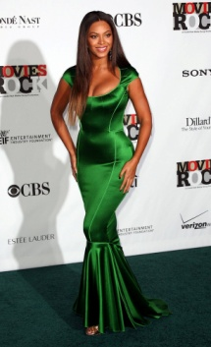

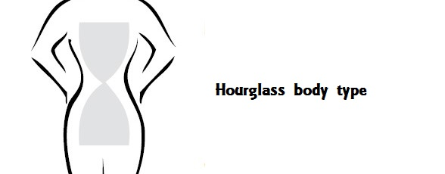

* 1. **Rectangle –** Hangs from shoulders to hem without a real waistline.

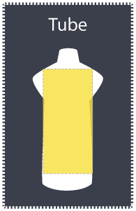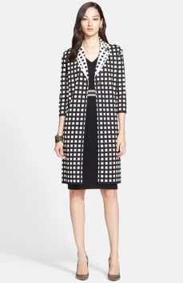

* 1. **Triangle –** Torso and upper body are narrower than the hips.

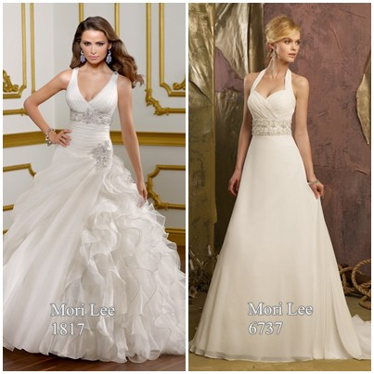

* 1. **Inverted Triangle –** Torso and upper body wider than your hips - with little waist definition

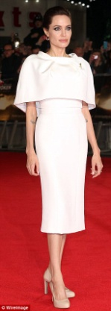

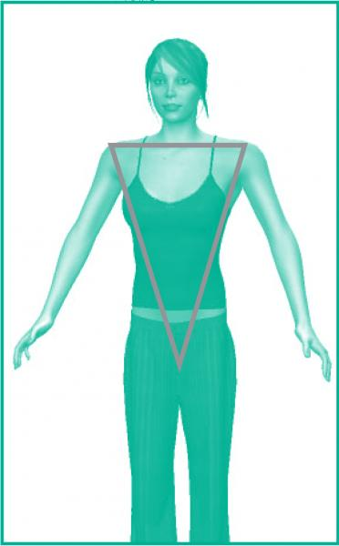

1. **Texture** (tactile, visual)
   1. **Tactile –** the actual feel of the surface
   2. **Visual –** the texture we see. Gives pleasure to our senses.
2. **Color –** *(more detailed in objective 2)*

a. Color has three dimensions or qualities: hue, value, and intensity.

e. **Pattern**

* 1. Naturalistic – realistic, appears as it would naturally
  2. Conventional/stylized – can recognize the object but is not realistic in appearance
  3. Geometric – based on lines and shapes
  4. Abstract – separate from anything recognizable in the real world

**Objective 2:** Reassess color theory (color wheel, hue, value, intensity, color schemes). **(*STEM Science)**

Color basics:

**a. Hue** – another term for color

**b. Primary** – cannot be broken into component parts. Red, yellow, blue

**c. Secondary** – created by combining two primary colors. Orange, green, violet

**d. Tertiary/intermediate** – created by combining a primary and secondary color. Red-orange,

red-violet, yellow-orange, yellow-green, blue-green, blue-violet.

**Color Wheel** – Locations of primary, secondary, and tertiary colors

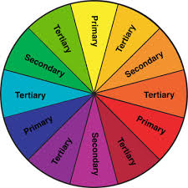

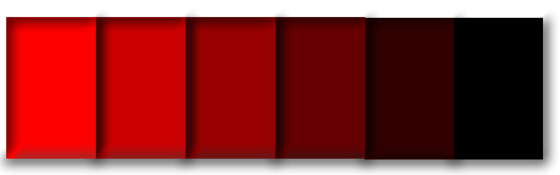**Value**: lightness or darkness

a. **Tints** – hue + white

b. **Shades** – hue + black

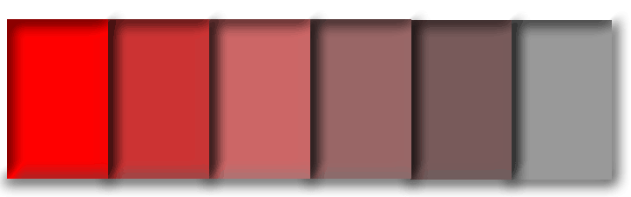

**Intensity**: brightness, dullness

a. **Tones** – add gray or complement

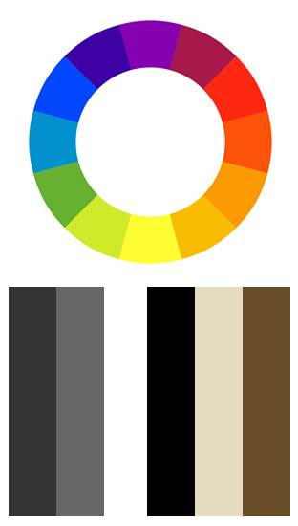

**Color Schemes:**

* 1. Neutral – the ‘non-colors’ black, white, tan, brown
  2. Accented neutral – mostly neutral with just a touch of color
  3. Monochromatic – tints and shade of one color
  4. Triadic – three colors evenly spaces on the wheel
  5. Analogous/adjacent – 2-4 colors next to each other on the wheel
  6. Complementary – two colors opposite on the color wheel

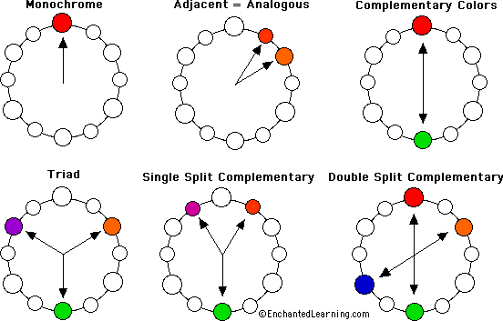



**Objective 3:** Reassess the principles of design (balance, emphasis, rhythm, proportion, and harmony). **(*STEM Math)**

**Balance:**

1. formal/symmetrical – the two sides of the design are mirror image
2. informal/asymmetrical – one side of the design does not reflect the other

**Emphasis:** focal point

**Rhythm:**

* 1. Gradation – gradual change in size or color
  2. Opposition – direct contrast created by perpendicular lines, black and white or complementary colors placed next to each other
  3. Radiation – lines extending from a central point
  4. Repetition – line, color or pattern repeated
  5. Transition – curved lines that lead from one area of a design to another

**Proportion/Scale**: the relationship of size of parts or objects in a design

**Harmony**: unity and variety

**Objective 4:** Identify careers in the fashion merchandising industry (personal stylist, set designer, etc.).

**Performance Objective 5:** Identify how each design principle can be used to enhance a person’s figure.

**STANDARD 8 - Students will describe basic consumer finance options.**

**Objective 1:** Define POS (point-of-sale). **(*STEM Technology, Math)**

1. The place at which goods are retailed. Could include a cash register or computer.

**Objective 2:** Develop skills necessary to identify garment quality. **(*STEM Science)**

a. Basic construction, seams, matching plaid, attachment of fasteners

**Objective 3:** Identify the various payment options available to consumers (cash, credit, layaway). **(*STEM Math)**

1. Cash – Use money to pay for the full cost of what you buy
2. Credit – A promise to pay for goods and services in a certain specified way at a later date. Buy now, pay later. A credit purchase can be made with a specific store charge account or with a general credit card.
3. Layaway – A store puts the item away for you for a certain length of time with a deposit toward buying it. The item must be paid in full before you can receive it.

**Objective 4:** Define the credit terms (credit limit, credit rating, 30-day charge account, revolving charge account, installment plan). **(*STEM Math)**

1. Credit Limit – Maximum financial amount a person may have outstanding on a charge or other credit account.
2. Credit Rating – Evaluation of the financial standing of a person or business based on past records of debt repayment, and financial status.
3. 30-Day Charge Account – Consumer credit arrangement whereby the bill must be paid in full within 30 days of the billing date. There is no extra finance charge on the bill.
4. Revolving Charge Account – Credit account that may be paid in full or in monthly payments with added finance charges but may not exceed a total predetermined credit limit.
5. Installment Plan – Credit arrangement by which a down payment is made on a large purchase, and a contract specifies the monthly payment and finance charges.

**Objective 5:** Identify careers in the fashion merchandising industry (garment inspector, sales, etc). **(STEM: Technology)**

STANDARD 9 – Students will develop professional and interpersonal skills needed for success in the fashion industry. Hard skills are specific, teachable abilities that can be defined and measured. By contrast, soft skills are less tangible and harder to quantify.

Objective 1: Identify soft skills needed in the workplace

* Strong work ethic
* Positive attitude
* Good communication skills
* Time management abilities
* Problem-solving skills
* Acting as a team player
* Self-confidence
* Ability to accept and learn from criticism
* Flexibility/adaptability
* Working well under pressure

Objective 2: Identify hard skills needed in the workplace

* Forecasting
* Analyzing
* Communication
* Customer service

Objective 3: Apply hire-ability skills needed to gain employment

* The application
* The resume
* The cover letter
* The interview
* Follow-up & thank yous