TITLE: Natural Fibers Burn/Solubility/Microscope Observation
110 minute lab
BEHAVIORAL OBJECTIVE: Students will be able to:
- Compare and contrast burning characteristics of natural fibers
- Discover and analyze the shapes of natural fibers under the microscope
- Determine solutions that damage natural fibers; use solubility tests
STANDARD:
Objective 20.0113-0301
Identify basic fibers, the characteristics, use and care of each textile. National Standards 16.2.1, 16.2.2, 16.2.5

MOTIVATOR:  What is the difference between a fiber and a fabric? (fiber is the smallest unit in a textile-it makes the fabric)  What is the difference between natural fibers and manufactured fibers? (natural fibers are found in nature as a fiber-manufactured fibers are made by man-they might be made from natural ingredients, but still are put into fiber form by man [rayon]) |  | SUPPLIES:  None
TIME:
5 minutes
 | ACTIVITY #1 (TITLE AND DESCRIPTION:  Lecture for the lab-“What is the purpose of this lab?” | TIME:  10 minutes
CONTENT:  Standard test methods for fibers include qualitative and quantitative identification, as well as determination of physical features. When fiber content information is not available, it can be generally determined by a few simple tests. These tests-burning, microscopic observation, and solubility-are described on your lab sheets. Burning can identify the broad classes of cellulosic, protein, and thermoplastic fibers by ignition, odor, and residue. Microscopic observation and/or solubility in specific solvents can then usually distinguish fibers within each category. Testing methods and procedures are outlined by the AATCC and the ASTM organizations. We will be using both standards of testing throughout the semester. |  | SUPPLIES:  Lab report worksheets (see the end of the lesson)  Aprons under sink in FL 310  Gloves under sink in FL 310  Beakers in cabinet under desk  Take the supplies with me to ASTE 106
PROCESS QUESTIONS:
- What is the difference between a cellulosic fiber and a protein fiber? (Protein comes from an animal, cellulosic comes from a plant.)
- What is the AATCC? (American Association of Textile Chemists and Colorists.)
- What is the ASTM? (American Society for Testing and Materials.)
- Why perform all the tests on textiles? (Quality, identification, characteristics, end uses, etc.)
 | ACTIVITY #2 (TITLE AND DESCRIPTION:  Burn testing | TIME:  20 minutes
CONTENT:  AATCC test method 20-2002 (AATCC technical manual page 41)  Students will take samples of natural fiber fabrics and burn small pieces of fiber to determine the characteristics of the fibers when being burned. They will write their findings on their lab report.  Students will look at:  - The flame-whether the fabric approaches the flame or shrinks away from the flame. Does it burn itself out and smoke, leave burning embers, or continue to actively burn with a flame;  - The smoke-what color (i.e. black, grey, white);  - The smoke-what smell (i.e. burning hair, grass, chemicals);  - The ash-what color and consistency (i.e. soft bead, ash, hard, black, grey);  - Threading of the fiber-yes or no.  Precautions-  - Use the tweezers and not your fingers-it will be hot.  - Keep your body and hair away from the flame  - Work over the tin foil area to keep the ash off the tables and floors  - Use the smallest piece of sample possible (about ½ inch square): sometimes the flame travels in a hurry and smells bad if using a large piece.  - Be safe! |  | SUPPLIES:  Matches  Tea light candles  Candle holders  Metal picks  Tweezers  Tin foil  Fabric swatches of:  - cotton  - flax  - jute  - silk  - wool  - cotton children’s sleepwear
PROCESS QUESTIONS:
- Did any of the fibers tested thread out? (No because they are all natural fibers.)
- Was there a difference between the cellulosic fibers and the protein fibers? (protein fibers smoke, smell, melting, shrinking, and continuing to burn are all different)
 | ACTIVITY #3 (TITLE AND DESCRIPTION:  Solubility testing | TIME:  20 minutes
CONTENT: AATCC test method 20-2002 (AATCC technical manual page 42)  Students will take samples of the natural fibers and place a ½” square piece in a beaker of solution and barely cover the sample with the solution. Stir the solution. After 3 minutes, they will see if there is any reaction to the fabric. They will check for a reaction again after 10 minutes.  Reactions may include:  - Soluble (dissolves)  - Insoluble (no change)  - Forms plastic mass  Students will test 3 samples of their choice in 3 solutions.  Precautions-  - Wash immediately if any solution comes in contact with your skin  - Keep it out of your eyes and off your face  - Wear gloves  - Wear an apron to protect your clothing  - Be Safe! |  | SUPPLIES:  Beakers  Stir sticks  Acetone  Bleach (Sodium Hypochlorite)  Vinegar (acetic acid)  Salicylic Acid (beta hydroxy acid derived from the bark of the willow tree)  Sulfuric Acid  Samples of :  - cotton  - flax  - jute  - silk  - wool  - cotton children’s sleepwear
PROCESS QUESTIONS:
1. What reactions surprised you? (answers will vary)
 | ACTIVITY #4 (TITLE AND DESCRIPTION:  Microscope Observation | TIME:  20 minutes
CONTENT: AATCC test method 20-2002 (AATCC technical manual pages 44-54)  Students will look at the slides under the microscope. On their lab report, there will be space for them to draw the longitudinal view of the fiber under 500 x magnifications. Slides will be pre-plated with distilled water and numbered 1-9 by the instructor. Students will try to identify what the fibers are using the illustrations in the AATCC technical manual. |  | SUPPLIES:  Raw fiber samples of:  - cotton  - flax  - silk  - wool  - jute  - ramie  - cashmere  - alpaca  - tussah silk  Microscopes  Slides  Distilled water  copies of microscope pictures from AATCC technical manual p. 44-54
PROCESS QUESTIONS:
- Do any of the fibers look the same? (answers will vary)
- Which fiber had the oddest shape? (answers will vary)
- How is wool different than the other fibers? (it has scales)

 | ACTIVITY #5 (TITLE AND DESCRIPTION:  Correcting Lab Reports | TIME:  10 minutes
CONTENT:  Students may use the table in their book to self-correct their lab reports. |  | SUPPLIES:  Fabric Science textbook  Tables on pages 28,30  Printed copies of the two tables
PROCESS QUESTIONS:
 | ACTIVITY #6 (TITLE AND DESCRIPTION:  Catch Up | TIME:
CONTENT:  Students may use the time to finish any lab work from the week before. |  | SUPPLIES:
PROCESS QUESTIONS:
SUMMARY:
Students will be able to roughly identify natural fibers using 3 simple tests-burning, solubility, and microscope.
STUDENT EVALUATION;
Lab #3 will be due at the beginning of class next week on January 29th by 3:30 p.m. They will be evaluated for completeness and accuracy.
There are 50 points possible for the lab and 20 attendance points. Points will be distributed as follows:
- 36 burn test table answers (each space answered) @ .66 points each
- 21 solubility answers @ .66 points each
- 18 microscope answers (sketch and label) @ .66 points each
Answer key (or diagrams and answer tables) follow lesson plan
TEACHER EVALUATION:
- Did the students accomplish the behavioral objectives?
- Did the transitions between activities go smoothly?
- What needs to be re-evaluated before teaching it next time?
OPTIONAL ACTIVITY:
Students may test samples out of their swatch kit to predict the characteristics of each of the tests. Reactions may vary due to blends of fibers, finishes, and dyes.
REFERENCES:
AATCC technical manual. (A. B. Chehna, Ed.) (2004, Vol. 79). Research Triangle Park, NC: American Association of Textile Chemists and Colorists.
Collier, B. J., & Epps, H. H. (1999). Textile testing and analysis. Upper Saddle River, New Jersey: Merrill.
Price & Cohen. Fabric science swatch kit.
http://www.sciencestuff.com/ Chemical solutions available for purchase. All solutions listed in Fabric science 8th edition p. 30, (table 2.3)

Lab #3 Lab Report
Burn/Solubility/Microscope Observation

- Burn Test
Procedure
    - Take a small piece (1/2 inch square) of the fabric sample (held in tweezers) and place close to the side of a small flame. Note if the fibers melt, shrink from the flame, or rush towards the flame.
    - Move the fibers into the flame. Note whether the fibers will burn when held in the flame. Remove from the flame very slowly and carefully. Note whether the fibers continue to burn outside of the flame. Make sure that the fiber was ignited before making this latter observation.
    - Blow out the flame, if still burning, and smell the smoke. Note the odor and examine the color and nature of any ash residue.
    - At the end of class, you may compare your answers to the observed behaviors of the fibers to the expected behaviors listed in your textbook.

Name of Fiber | Characteristics or Behaviors of the Fiber and the Flame
 | Does it melt, shrink from, or rush towards the flame as it approaches? | Does the fiber burn quickly,slowly, or not at all when in the flame? | Does the fiber continue to have an active flame or does it smolder after being removed from the flame? | What does the ash look like? (color, texture, etc.) | What does the smoke look like? (color, consistency, etc.) | What does the smoke smell like? (be descriptive)
Cotton

Flax

Jute

Silk

Wool

Cotton children’s Sleepwear

Additional Notes/Questions:

- Solubility Test
Procedure
  - Work in groups of 3. Each student will be responsible for recording the results on their own lab sheets.
  - Choose 3 fabrics to test and 3 solvents to test with.
  - At room temperature (20۫º C), place a small sample (1/2” square) of the fabric swatch in a 50 ml beaker and just barely cover with the chosen test solvent.
  - Let the fiber sit in the solution for 3 minutes.
  - Note if the fiber dissolves completely, softens to a plastic mass or remains insoluble.
  - Return and observe the test samples again after 10 minutes. Are there any changes?
  - At the end of class, you may compare your answers to the observed behaviors of the fibers to the expected behaviors listed in your textbook.

Name of Fiber |  | Characteristics or Behaviors of the Fiber and the Solution
 |  | Name of Solvents
1. | 3 min
1. | 10 min
2. | 3 min
2. | 10 min
3. | 3 min
3. | 10 min
Additional Notes/Questions:

- Microscope Observation
Procedure
  - Place the fibers plated in microscope slides into the microscopes and focus to 500x magnification.
  - Observe the fiber characteristics as seen in traverse sections and draw your observations in the circles provide.
  - Compare your drawn observations with the pictures provided in your textbook and in the AATCC Vol 79, 2004 reference book (pages 44-54) and label the appropriate samples.

Burn Chart
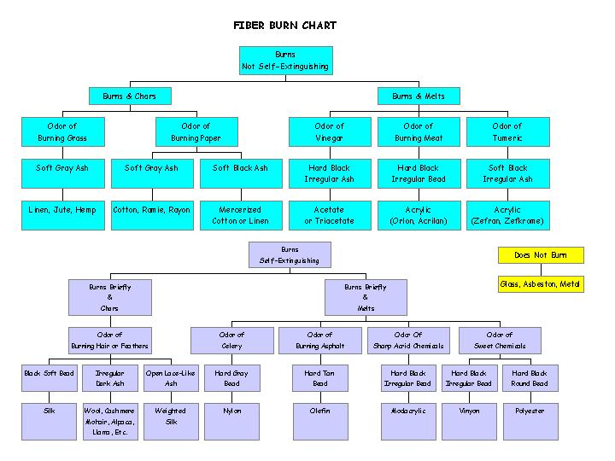
Solubility Answer Chart
Name of Fiber | Acetic Acid (vinegar) |  | Salicylic Acid (facial cleanser) | Sulfuric Acid (toilet cleaner) | Acetone (fingernail polish remover) | Hydrochloric acid (chlorine bleach)
cotton | Nothing | Nothing |  | Soluble | Nothing | Nothing
flax | Nothing | Nothing |  | Soluble | Nothing | Nothing
jute | Nothing | Nothing |  | Soluble | Nothing | Nothing
silk | Nothing | Nothing |  | Soluble | Nothing | Soluble
wool | Nothing | Nothing |  | Nothing | Nothing | Soluble
children’s sleepwear | Depends on fiber content of sleepwear-cotton would be soluble in sulfuric acid, wool and silk will be soluble in sodium hypochlorite, vinyon and acetate would be soluble in acetone, and acetate is soluble is acetic acid
Microscope Answer chart
Diagram is subjective grading-does it look like a diagram of a fiber?
Labeling

- alpaca
- cashmere
- cotton
- flax
- jute
- ramie
- silk
- tussah silk
- wool

